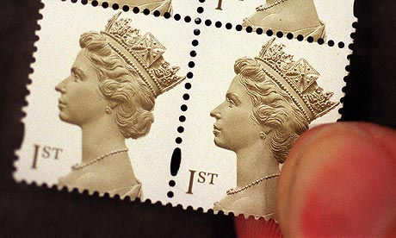

ASPS Congress National Stamp and Postcard Fair 2026 Everyone welcome! Free entry.

The Association of Scottish Philatelic Societies (ASPS) is holding its annual stamp and postcard fair on Friday 10th and Saturday 11th April 2026.

Venue: The Vine Conference Centre, 131 Garvock Hill, Dunfermline, Fife, KY11 4JU
(5 minutes from the M90 and approx. 30 minutes north of Edinburgh)

Friday 10th April 10am – 5pm
Saturday 11th April 10am – 3pm (incl. Children’s Activities Day)

More than 20 stamp and postcard dealers from across the UK will be attending.

This event is sponsored by David Feldman International Auctioneers.


