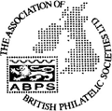
ABPS

The Association of British Philatelic Societies Ltd

EXECUTIVE BULLETIN May 2022

Please circulate this bulletin to any philatelic friends to show what the ABPS is doing to promote philately across the UK. Also please visit www.abps.org.uk

PHILATELIC CONGRESS OF GREAT BRITAIN

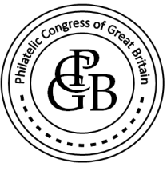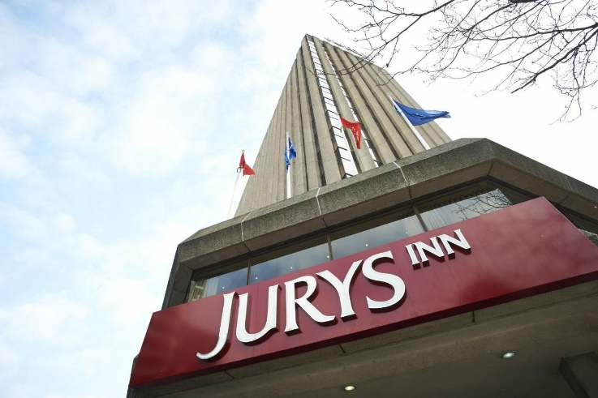

This year’s Philatelic Congress of Great Britain is being held at the Jurys Inn Hotel, 245 Broad Street, Birmingham (centre of the city) from Thursday, 8 September 2022 to Sunday, 11th September 2022.
The theme of the Congress is going to be “Organised Philately” – how our hobby is organised in different ways. During Congress there will be input from local societies, specialist societies, national societies, international societies, the philatelic trade and international philatelic organisations demonstrating what each type of society or organisation brings to the hobby – and displaying what is collected!
The booking form and programme can be found on the ABPS website.
www.abps.org.uk/congress
or for more information contact Seven Harrison, Chairman of ABPS, by emailing him at sharrison500@btinternet.com or calling him on 0121 313 0671.

STAMPEX

Autumn Stampex 2022 will be held from 28th September to 1st October at the Business Design Centre, London. The theme of the event will be “Africa” with invited displays from leading specialist societies in that area of collecting as well as the full range of competitive exhibits.

ABPS would welcome offers of sponsorship for the frames. If any Society or individual can help, please contact Simon Richards at simon@sidebell.co.uk

STAMP ACTIVE NETWORK

Stamp Active will be at Stampex with free goodie bags for children and free activities including stamp art. The theme of the activities will be “All Creatures Great and Small”, so look out for some fun animals and displays.

50 youngsters will receive a £20 in vouchers to spend with dealers at the Show.

£20 in Vouchers 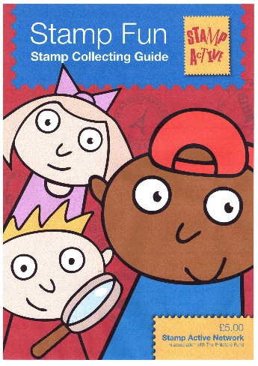

Copies of a new Stamp Collecting Guide at the show which will be available at the show to all young collectors.

Latest information about all Stamp Active activities can be found on their award-winning website at www.stampactive.co.uk
Email: stampactive@btinternet.com

ABPS ADVERISING MANAGER

Eddie Mays is stepping down from his role as Advertising Manager from July 2022. If you are prepared to help, please contact us.
INTERNATIONAL EXHIBITIONS

Full details of opportunities to take part in international stamp exhibitions can be found in the Exhibiting section of the ABPS website.

HELVETIA 2022 Lugano, Switzerland 18 - 22 May 2022
FIP specialised international exhibition with FEPA recognition most classes invited.
UK Commissioner: Chris King ( Chris.King@postalhistory.net )
Information is at www.helvetia2022.ch
Entry deadline: Closed
CAPEX 2022 Toronto, Canada 9-12 June 2022
World One Frame Stamp Championship
UK Commissioner: Simon Moorcroft ( simon.moorcroft@btinternet.com )
Information is at: www.capex2022.org
Entry deadline: Closed
LIBEREC 2022 Liberec, Czech Republic 13-16 October 2022
FEPA patronage with FIP recognition.
UK Commissioner: Steve Harrison (sharrison500@btinternet.com ).
Classes invited include Traditional, Postal History, Thematic and Picture Postcard).
Information is at www.liberec2022.eu
Entry deadline: Closed
SOUTH AFRICA 2021, Cape Town, South Africa 8-12 November 2022
FIP patronage.
UK Commissioner: Jon Aitchison (britishlocals@aol.com )
Further information on classes, dates and IREX is at www.capetown2021.org
Entry deadline 15 May 2022
IBRA 2021, Essen, Germany 25 – 28 May 2023
FIP specialised international exhibition with FEPA recognition.
UK Commissioner: Graham Winters.
Classes invited include Traditional, Postal History, Thematic and Picture Postcard). www.ibra2021.de

ABPS AWARDS

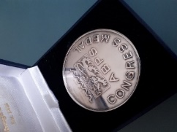 Congress Medal

The Awards Committee invites nominations for the Awards. See the website for nomination forms and full details of the Award of Merit and Congress Medal.

ABPS SMALL GRANTS SCHEME

The ABPS is always there to help! If you are planning a local event to promote philately and may need financial assistance, please have a look at this scheme on our website as you may be eligible for a grant.

In particular, there may be some small societies of less than ten members who made need financial help to keep going. ABPS is very willing to consider financial support.

ABPS NEWS

The closing date for copy for the next issue is 15th July, followed by 15th October.
Articles and enquiries relating to ABPS News can be submitted via the website
or you can write direct by email at editor@abps.org.uk
This is an opportunity for you to promote your Society. Affiliated Societies and Federations are entitled to one free advertisement each year.

LATEST NEWS FROM ROYAL MAIL
Please note Non-barcoded Definitive stamps will be phased out but will remain usable until 31 January 2023.

Royal Mail is encouraging customers to find any non-barcoded stamps they have at home so they can use them up, unused stamps will be exchangeable under a ‘Swap Out’ scheme.

CALLING ALL STAMP EVENT ORGANISERS

As we re-emerge from the pandemic, events are now being re-organised and new ones planned. The new website of the ABPS provides the opportunity for organisers of philatelic events such as Stamp Fairs, Philatelic Exhibitions, Society Weekends and Regional Society Meetings, to promote their events free of charge. It is also a chance, if you are planning an event, to check that it does not clash with anything else.

You can request an event to be added to the ABPS Events Calendar directly on the website. Entries will then be checked by the administrator and approved.

Go to https://www.abps.org.uk/request-event-addition/

CALLING ALL SPEAKERS

If you are prepared to give displays to Societies, either in person or by Zoom, please pass your details to the Secretary of ABPS or input your information on to ABPS website. We will be updating the site with additional information about speakers relating to Powerpoint presentations as this has become a popular development resulting from the pandemic.

MAKE SURE YOUR SOCIETY LOOKS GOOD ON THE NEW ABPS WEBSITE

Our website has received some very positive feedback so far but we know there is more that can be done. It is the same address www.abps.org.uk

It is on a new platform and includes all the usual information about ABPS news and activities. It now also includes a searchable list of speakers, judges and an events calendar.

If you are a speaker or judge or an event organizer, please check the information on the website and advise us of any corrections, updates or additions.

If you are a Society or Speaker, you can add some pictures of your meetings or displays to create attractive content.

If you have any images of your local Society, events or seminars etc. that you think might enhance the website please send them to the Communications Director, Alan Godfrey at communications@abps.org.uk

FOR MORE INFORMATION, OR TO GIVE YOUR COMMENTS,

Please contact those mentioned above, or E-mail: secretary@abps.org.uk
Any feedback or ideas, or if you would like to help, please contact our Chairman, Steve Harrison, by email: chair@abps.org.uk
The postal address for all ABPS correspondence is: ABPS, 15 Abchurch Lane, London, EC4N 7BW

