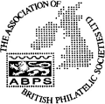
ABPS

The Association of British Philatelic Societies Ltd

EXECUTIVE BULLETIN February 2022

Please circulate this bulletin to any philatelic friends to show what the ABPS is doing to promote philately across the UK. Also please visit www.abps.org.uk

LONDON 2022 IS NEARLY HERE

The London 2022 event has attracted dealers from all over the world. It is being held at the Business Design Centre, Islington, from 19th to 26th February 2022 and will also feature 3400 frames of competitive exhibits. It is an event not to be missed.

Amongst the attractions will be a Youth Zone on the mezzanine level (lhs) which will also include “Ask the Expert” where both youngsters and adults can chat about Getting Started, the tools of the trade, competitive exhibiting, using Computers in Philately and much more…

On Sunday 20th February there will be a FEPA Seminar on “Best Practice in Youth Philately” by John Davies.
On Friday 25th February there will be a FEPA Seminar on Digitisation and Social Media by Dr Eric Scherer.

A number of specialist societies will be promoting themselves on “Society Day” on Wednesday 23rd February.

Full details of the Exhibition and a listing of all the exhibits can be found on the London 2022 website www.london22.co where there have been regular newsletters and announcements. Entry is free on all days except the first day (£10).

Look out for the ABPS table on the Gallery Bay, booth number G15a. Please call and say hello. There is likely to be a daily bulletin on Facebook and the ABPS website by ABPS Editor, Keith Burton, so watch out for the news from London 2022.

STAMP ACTIVE NETWORK

Stamp Active will be at London 2022 International Exhibition with free goodie bags for children and free activities including stamp art. They will have a large stand at the far end of the mezzanine (left side) thanks to the generous support of the Spear Charitable Trust.

100 youngsters will receive a £20 in vouchers to spend with dealers at the Show.

£20 in Vouchers 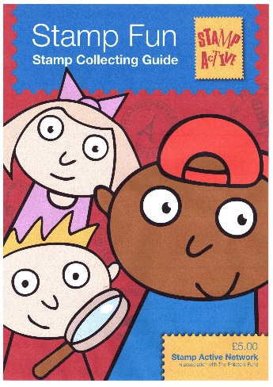

Stamp Active will also be launching a new Stamp Collecting Guide at the show which will be provided free of charge to all young collectors.

Latest information about all Stamp Active activities can be found on their award-winning website at www.stampactive.co.uk
Email: stampactive@btinternet.com

SCOTTISH CONGRESS/NATIONAL EXHIBITION

The 91st Scottish Annual Congress will take place from 22nd - 23rd April 2022 at the Dewars Centre, Perth

The hosts will be the Perth Philatelic Society. Rev. J. Colin Caske will act as President.

Entry forms for all competitions at the National Exhibition (National Exhibition, Alan Watson Memorial Competition, Junior Competitions for the ALBA Salver and One-Sheet Competition) are now available to download on the Congress page. www.scottishphilately.co.uk/congress

PHILATELIC CONGRESS OF GREAT BRITAIN

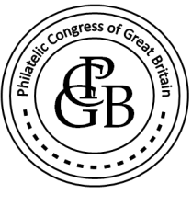

Planning for the 2022 Congress has started. It is from 8th to 11th September in Birmingham at Jury’s Inn …an important date for your diary!

ABPS ADVERISING MANAGER

Eddie Mays is stepping down from his role as Advertising Manager from July 2022. If you are prepared to help, please contact us.

THE FUTURE OF ABPS

New Chairman, Steve Harrison, has initiated a grass roots review of the future of ABPS with thought being given to key objectives including the Vision for 2030, Raising the profile of ABPS, Building Relationships with stakeholders, Building Benefits for Affiliated Societies and Fund-Raising.
Do you have any suggestions on what ABPS should be doing in the future?
Please contact Steve Harrison, by email: chair@abps.org.uk

STAMPEX

Autumn Stampex 2022 will be held from 28th September to 1st October at the Business Design Centre, London

INTERNATIONAL EXHIBITIONS

Full details of opportunities to take part in international stamp exhibitions can be found in the Exhibiting section of the ABPS website.

- National Exhibitions in the UK

Autumn Stampex, Business Design Centre 28 September – 1 October 2022
Theme – Africa. Competitive exhibition

- International Exhibitions with UK Participation

HUNFILEX 2022 Budapest, Hungary 31 March -3 April 2022
FIP specialised international exhibition with FEPA recognition postal history, traditional, revenue, thematic, open, literature
UK Commissioner: Bill Hedley (ewlhedley@gmail.com )
Information is at http://mabeosz.hu/hunfilex2022
Entry deadline: Closed UK entries accepted
HELVETIA 2022 Lugano, Switzerland 18 - 22 May 2022
FIP specialised international exhibition with FEPA recognition most classes invited.
UK Commissioner: Chris King ( Chris.King@postalhistory.net )
Information is at www.helvetia2022.ch
Entry deadline: Closed
CAPEX 2022 Toronto, Canada 9-12 June 2022
World One Frame Stamp Championship
UK Commissioner: Frank Walton (frank@frankwalton.com ).
Information is at: www.capex2022.org
Entry deadline: Closed
LIBEREC 2022 Liberec, Czech Republic 13-16 October 2022
FEPA patronage with FIP recognition.
UK Commissioner: Steve Harrison (sharrison500@btinternet.com ).
Classes invited include Traditional, Postal History, Thematic and Picture Postcard).
Information is at www.liberec2022.eu
Entry deadline: 28th February 2022
SOUTH AFRICA 2021, Cape Town, South Africa 8-12 November 2022
FIP patronage.
UK Commissioner: Jon Aitchison (britishlocals@aol.com )
Further information on classes, dates and IREX is at www.capetown2021.org
Entry deadline 15 May 2022
IBRA 2021, Essen, Germany 25 – 28 May 2023
FIP specialised international exhibition with FEPA recognition.
UK Commissioner: Frank Walton (frank@frankwalton.com ). Classes invited include Traditional, Postal History, Thematic and Picture Postcard). www.ibra2021.de
Entry deadline: opening soon
ABPS AWARDS

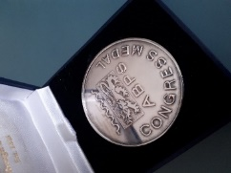 Congress Medal

The Awards Committee invites nominations for the Awards. See the website for nomination forms and full details.

ABPS NEWS

The closing date for copy for the next issue is 15th April, followed by 15th July Articles and enquiries relating to ABPS News can be submitted via the website
or you can write direct by email at editor@abps.org.uk
This is an opportunity for you to promote your Society. Affiliated Societies and Federations are entitled to one free advertisement each year.

ABPS SMALL GRANTS SCHEME

The ABPS is always there to help! If you are planning a local event to promote philately and may need financial assistance, please have a look at this scheme on our website as you may be eligible for a grant.

LATEST NEWS FROM ROYAL MAIL
Please note Non-barcoded Definitive stamps will be phased out but will remain usable until 31 January 2023.

Royal Mail is encouraging customers to find any non-barcoded stamps they have at home so they can use them up, unused stamps will be exchangeable under a ‘Swap Out’ scheme.

CALLING ALL STAMP EVENT ORGANISERS

As we re-emerge from the pandemic, events are now being re-organised and new ones planned. The new website of the ABPS provides the opportunity for organisers of philatelic events such as Stamp Fairs, Philatelic Exhibitions, Society Weekends and Regional Society Meetings, to promote their events free of charge. It is also a chance, if you are planning an event, to check that it does not clash with anything else.

You can request an event to be added to the ABPS Events Calendar directly on the website. Entries will then be checked by the administrator and approved.

Go to https://www.abps.org.uk/request-event-addition/

CALLING ALL SPEAKERS

If you are prepared to give displays to Societies, either in person or by Zoom, please pass your details to the Secretary of ABPS or input your information on to ABPS website. We will be updating the site with additional information about speakers relating to Powerpoint presentations as this has become a popular development resulting from the pandemic.

MAKE SURE YOUR SOCIETY LOOKS GOOD ON THE NEW ABPS WEBSITE

Our website has received some very positive feedback so far but we know there is more that can be done. It is the same address www.abps.org.uk

It is on a new platform and includes all the usual information about ABPS news and activities. It now also includes a searchable list of speakers, judges and an events calendar.

If you are a speaker or judge or an event organizer, please check the information on the website and advise us of any corrections, updates or additions.

If you are a Society or Speaker, you can add some pictures of your meetings or displays to create attractive content.

If you have any images of your local Society, events or seminars etc. that you think might enhance the website please send them to the Communications Director, Alan Godfrey at communications@abps.org.uk

FOR MORE INFORMATION, OR TO GIVE YOUR COMMENTS,

Please contact those mentioned above, or E-mail: secretary@abps.org.uk
Any feedback or ideas, or if you would like to help, please contact our Chairman, Steve Harrison, by email: chair@abps.org.uk
The postal address for all ABPS correspondence is: ABPS, 15 Abchurch Lane, London, EC4N 7BW

