ABPS

The Association of British Philatelic Societies Ltd

EXECUTIVE BULLETIN March 2021

Please circulate this bulletin to any philatelic friends to show what the ABPS is doing to promote philately across the UK. Also please visit www.abps.org.uk

MIDPEX 2021 GOING AHEAD
MIDPEX 2021
Warwickshire Event Centre, Leamington Spa, CV31 1XN
3rd July 2021 10:00am – 4:30pm

Plans for MIDPEX, sponsored by Cavendish Philatelic Auctions Ltd. have been confirmed and Dealers and Societies are now booking up for this popular and successful Show. Organiser, Steve Harrison, commented “We have been through some difficult times with the Covid 19 pandemic. As the vaccination programme continues, there is renewed confidence that the event can go ahead safely. Dealers are enthusiastic about the show and many of them, as well as the Specialist Societies, have confirmed they will take part”. All of this is subject to any future government restrictions, of course, but the outlook seems extremely promising”.
MIDPEX is the biennial exhibition first held in 1995 and attended by stamp collectors from across the UK. It brings together Specialist Societies with local, national and international dealers covering all aspects of Philately. The venue is the same, although there has been a slight change of name.
It provides an opportunity for Specialist Societies to show off their sphere of interest to other collectors, to recruit members and identify common ground with members of other Societies. It also provides an opportunity for Societies to promote their publications and research projects and for members to meet informally, particularly those members who find it difficult to get to meetings in London. The event in 2021 will be further expanded with space for post card dealers as well as stamps, thematics and postal history. There is only space for 70 dealers and 40 Specialist Societies are expected to support the Show.
For more information and booking forms please contact Steven Harrison by email: sharrison500@btinternet.com
Additional details of the venue with views of the hall and site location including parking, can be accessed on https://www.warwickshireeventcentre.co.uk
VIRTUAL SPRING STAMPEX 2021

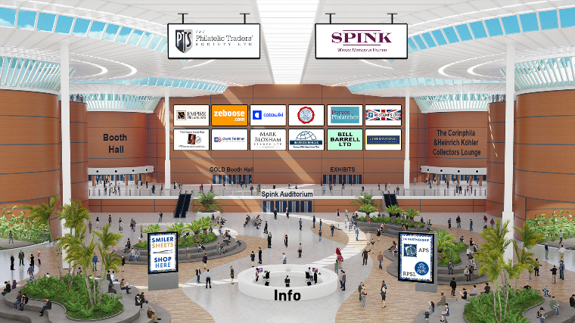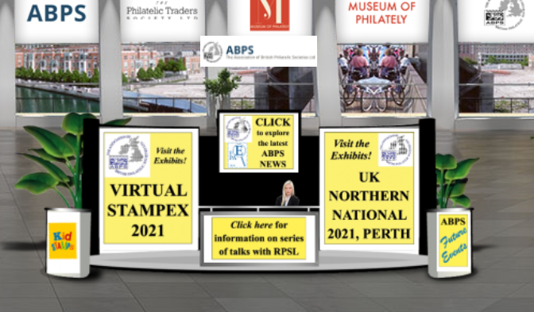

Stampex was on line from 25th to 27th March with booths remaining open thereafter for several months. The virtual events seem to have been well received. ABPS featured as part of the Exhibition and competitive entries were on show in a separate Hall for both Stampex and the Perth national exhibition (98 frames) and the Stamp Active one page youth competition (20 entries).

Planning for Autumn Stampex is going ahead at the Business Design Centre, Islington, London, from Wednesday 29th September to 2nd October. The lead Society will be the British Thematic Association with over 150 frames of displays.

INTERNATIONAL EXHIBITIONS

Full details of opportunities to take part in international stamp exhibitions can be found in the Exhibiting section of the ABPS website. They are not detailed here as the situation remains very volatile in the light of the current crisis.

We were saddened to learn of the passing of Christine Earle who was a popular exhibitor and judge. We send our condolences to her daughter, Sam, and partner, Pat.

PHILATELIC CONGRESS OF GREAT BRITAIN

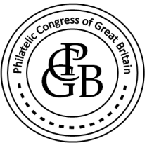

The 2021 Congress will, hopefully, be held in Harrogate to recognise 100 Years since its formation there. This will take place from 23rd September to 26th at the Crowne Plaza Hotel.
For more information, see the ABPS website or contact gerald.marriner@gmail.com

ABPS AWARDS

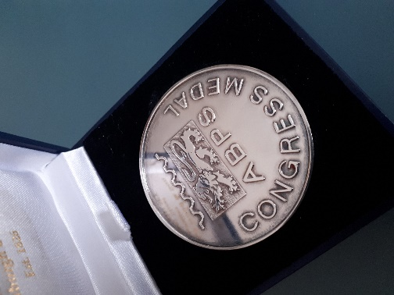 Congress Medal

Nominations for the ABPS Award of Merit and Congress Medal are always welcome. Full details and nomination forms can be found on the ABPS website.
The awards for 2021 will be announced shortly.

ABPS NEWS

The closing date for copy for the next issue is 15th April.
Articles and enquiries relating the ABPS News can be submitted via the website
or you can write direct by email at editor@abps.org.uk

NATIONAL STAMP DAY

Don’t forget the anniversary of the stamp on 6th May each year. Could your Society or yourself plan something special to promote philately?

STAMP ACTIVE NETWORK

Peter Barham has now taken over as Secretary.
Stamp Active has prepared a new Guide to Stamp Collecting for youngsters and this can be downloaded from their website.
Latest information about all Stamp Active activities can be found on their award-winning website at www.stampactive.co.uk
Email: stampactive@btinternet.com

ABPS SMALL GRANTS SCHEME

The ABPS is always there to help! If you are planning a local event to promote philately and may need financial assistance, please have a look at this scheme on our website as you may be eligible for a grant.

CALLING ALL STAMP EVENT ORGANISERS

As we re-emerge from the pandemic, events are now being re-organised and new ones planned. The new website of the ABPS provides the opportunity for organisers of philatelic events such as Stamp Fairs, Philatelic Exhibitions, Society Weekends and Regional Society Meetings, to promote their events free of charge. It is also a chance, if you are planning an event, to check that it does not clash with anything else.

You can request an event to be added to the ABPS Events Calendar directly on the website. Entries will then be checked by the administrator and approved.

Go to https://www.abps.org.uk/request-event-addition/

CALLING ALL SPEAKERS

If you are prepared to give displays to Societies, either in person or by Zoom, please pass your details to the Secretary of ABPS or input your information on to ABPS website. We will be updating the site with additional information about speakers relating to Powerpoint presentations as this has become a popular development resulting from the pandemic.

MAKE SURE YOUR SOCIETY LOOKS GOOD ON THE NEW ABPS WEBSITE

Our new website has received some very positive feedback so far but we know there is more that can be done. It is the same address www.abps.org.uk

It is on a new platform and includes all the usual information about ABPS news and activities.
It now also includes a searchable list of speakers, judges and an events calendar.

If you are a speaker or judge or an event organizer, please check the information on the website and advise us of any corrections, updates or additions.

If you are a Society or Speaker, you can add some pictures of your meetings or displays to create attractive content.

If you have any images of your local Society, events or seminars etc. that you think might enhance the website please send them to the Communications Director, Alan Godfrey at communications@abps.org.uk

FOR MORE INFORMATION, OR TO GIVE YOUR COMMENTS,

Please contact those mentioned above, or E-mail: secretary@abps.org.uk
Any feedback or ideas, or if you would like to help, please contact our Chairman, Graham Winters, by email: j.g.winters@hotmail.co.uk
The postal address for all ABPS correspondence is: ABPS, 15 Abchurch Lane, London, EC4N 7BW

