ABPS

The Association of British Philatelic Societies Ltd

EXECUTIVE BULLETIN November 2020

Please circulate this bulletin to any philatelic friends to show what the ABPS is doing to promote philately across the UK. Also please visit www.abps.org.uk

VIRTUAL AUTUMN STAMPEX 2020

Stampex went on line from 1st to 3rd October with booths remaining open until the end of the year. The virtual event seems to have been well received. ABPS featured as part of the Exhibition. There were 26 entries in the national one frame competition and 24 in the Inter Federation Competition. The entries also remain available to view until the end of the year. The ABPS booth was visited on 613 occasions by 389 different attendees.

ABPS ZOOM SESSIONS

Following the success of a number of online presentations from various philatelic organisations including the RPSL and GBPS. A number of these are available to view on You Tube including the presentations from the recent Postal History Symposium.

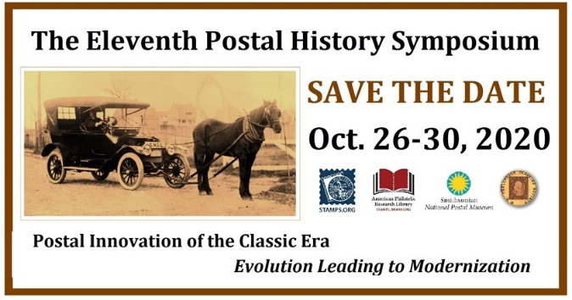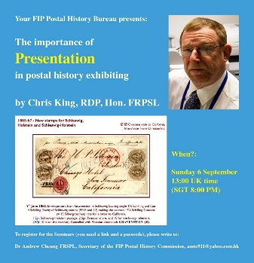

other Societies are also trying out online meetings. The ABPS would like to publicise these, so please use the ABPS website to provide details of these events. https://www.abps.org.uk/request-event-addition/

We will also be contacting speakers to find out if details of their interest in giving such presentations should be added to the speakers list on the website.
We would like to hear your views. Please email pr@abps.org.uk with any feedback.

INTERNATIONAL EXHIBITIONS

Full details of opportunities to take part in international stamp exhibitions can be found in the Exhibiting section of the ABPS website. They are not detailed here as the situation remains very volatile in the light of the current crisis.

PHILATELIC CONGRESS OF GREAT BRITAIN

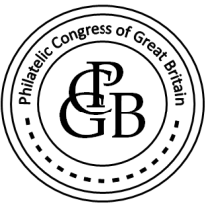
The Philatelic Weekend planned for Market Harborough on Saturday 20th and Sunday 21st March 2021 has been cancelled due to the continuing situation with Coronavirus. pandemic

The 2021 Congress will, hopefully, be held in Harrogate to recognise 100 Years since its formation there.
For more information contact gerald.marriner@gmail.com

ABPS AWARDS

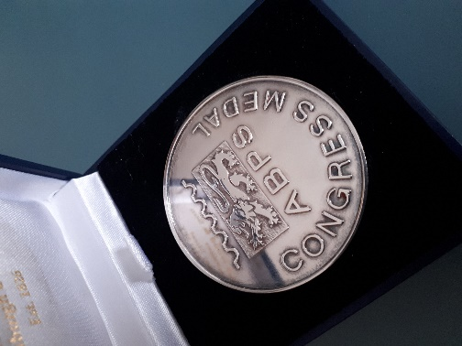 Congress Medal

Nominations for the ABPS Award of Merit and Congress Medal can be made until 31st March. Full details and nomination forms can be found on the ABPS website.

ABPS NEWS

The closing date for copy for the next issue is 15th January.
Articles and enquiries relating the ABPS News can be submitted via the website
or you can write direct by email at editor@abps.org.uk

STAMP ACTIVE NETWORK

Secretary, Ray Watkins will be standing down at the end of the year and will be replaced by Peter Barham.
Latest information about all Stamp Active activities can be found on their award-winning website at www.stampactive.co.uk
Email: stampactive@btinternet.com

ABPS SMALL GRANTS SCHEME

The ABPS is always there to help! If you are planning a local event to promote philately and may need financial assistance, please have a look at this scheme on our website as you may be eligible for a grant.

CALLING ALL STAMP EVENT ORGANISERS

The newly-launched website of the ABPS provides the opportunity for organisers of philatelic events such as Stamp Fairs, Philatelic Exhibitions, Society Weekends and Regional Society Meetings, to promote their events free of charge.

You can request an event to be added to the ABPS Events Calendar directly on the website. Entries will then be checked by the administrator and approved.

Go to https://www.abps.org.uk/request-event-addition/

Chairman of the ABPS, Graham Winters, commented “One of the common challenges for organisers of philatelic events is to avoid clashes with other major philatelic events. We hope that the new ABPS Events Calendar will be the “go to” place to check the diary to minimise such problems in the future.”

MAKE SURE YOUR SOCIETY LOOKS GOOD ON THE NEW ABPS WEBSITE

Our new website has received some very positive feedback so far but we know there is more that can be done. It is the same address www.abps.org.uk

It is on a new platform and includes all the usual information about ABPS news and activities.
It now also includes a searchable list of speakers, judges and an events calendar.

If you are a speaker or judge or an event organizer, please check the information on the website and advise us of any corrections, updates or additions.

If you are a Society or Speaker, you can add some pictures of your meetings or displays to create attractive content.

If you have any images of your local Society, events or seminars etc. that you think might enhance the website please send them to the Communications Director, Alan Godfrey at communications@abps.org.uk

FOR MORE INFORMATION, OR TO GIVE YOUR COMMENTS,

Please contact those mentioned above, or E-mail: secretary@abps.org.uk
Any feedback or ideas, or if you would like to help, please contact our Chairman, Graham Winters, by email: j.g.winters@hotmail.co.uk
The postal address for all ABPS correspondence is: ABPS, 15 Abchurch Lane, London, EC4N 7BW

